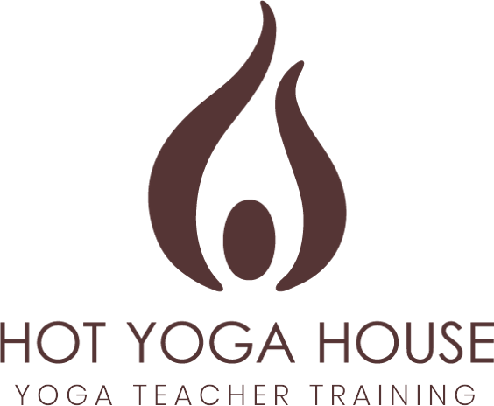

Thank you for your interest in the 2022 HYH Teacher Training program.
Yoga teacher training is a life changing experience, and we are honoured you are taking this step with us. We have designed this program to provide you with the most authentic teachings, taught by two of the longest serving, and most respected senior teachers in Hot Hatha Yoga and Vinyasa Yoga in the UK.
To ensure interest and dedication to the program, applicants must have a minimum of two years’ experience with yoga. All applicants are required to fill out this application before acceptance into the program.
When complete, please send your form to info@hotyogahouse.co.uk

PERSONAL INFO
Name
DOB
Address
Gender | Male Female Rather not say
Occupation
Emergency contact | Name:  Contact Phone:  Relationship:

DESCRIBE YOUR YOGA PRACTICE:

How long have you been practicing for? How often do you practice?

What style(s) of yoga do you practice?

Who have been your most influential teachers and why?

A LITTLE MORE ABOUT YOU:

What led you to yoga?

What does yoga mean to you?

Why do you want to be a certified yoga teacher?

What do you think makes a good yoga teacher?

What do you hope to gain and/or learn on this course?

Do you have any relevant qualifications / training / experience?

What do you think will be most challenging for you?

Do you have any injuries or any medical conditions we should be aware of?

Please explain your willingness to be fully committed and attend 100% of the training.

Anything else you would like us to know about you?

Our Policy
Upon acceptance of your application there will be a non-refundable deposit of £500 to secure your place on this course
Teacher Training Certificates are not given solely based on requirements met. Full participation is required.
Each graduate is assessed based on their understanding of the curriculum in addition to their attendance.
Thank you again and please feel free to contact us with any questions you may have.

I HAVE READ AND UNDERSTAND THE ABOVE TERMS AND REQUIREMENTS.

Name: __________________ Date: __________________

How did you hear about our program?

Thank you for your interest in our program.
We look to forward to the opportunity to guide you on your journey to becoming a certified teacher and will be in touch soon to let you know if your application has been accepted.

The HYH YTT Team

